**24.AWS-S3 Glacier & Storage Gateway & AWS Backup**

**AWS-S3 Glacier**

You have an old data and don’t need changes, you want to archive it, then only you use this feature.

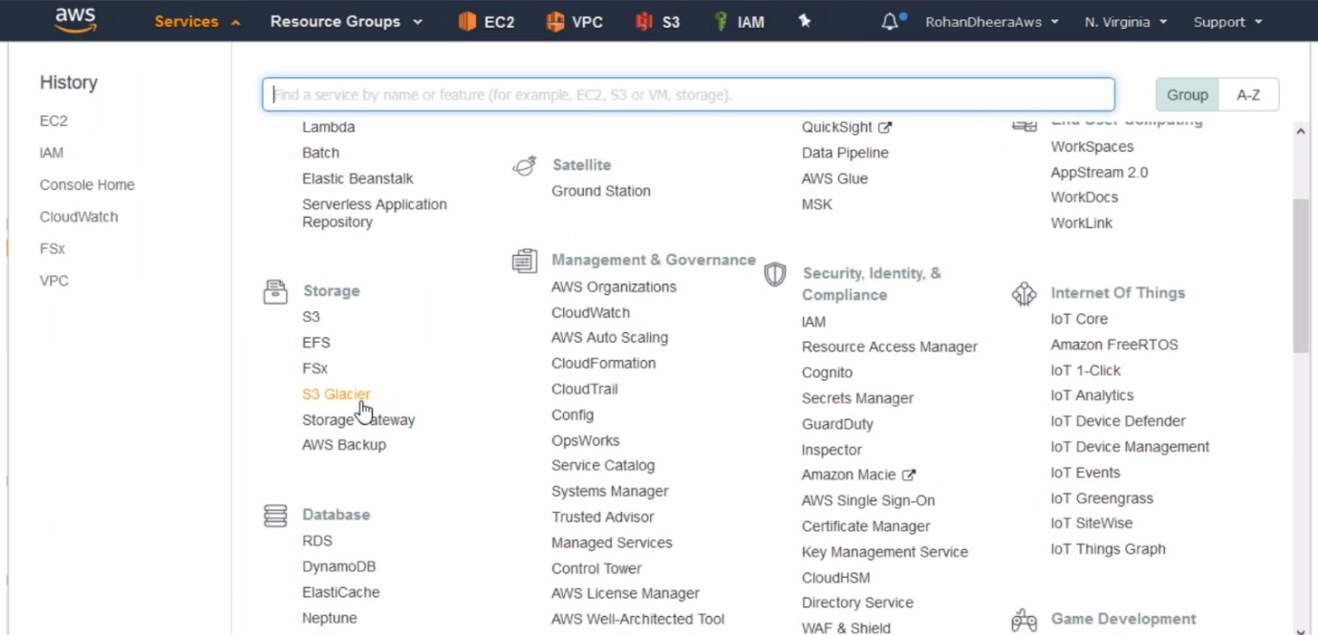

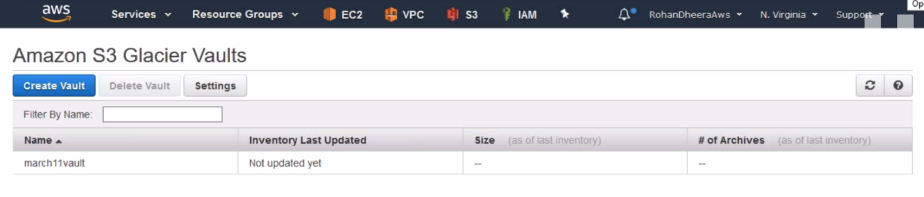

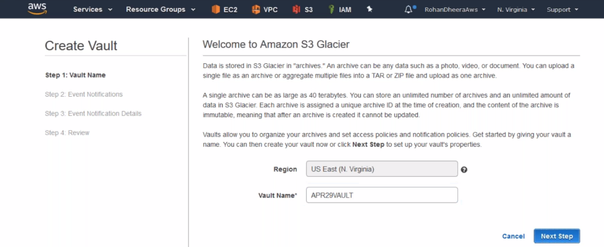

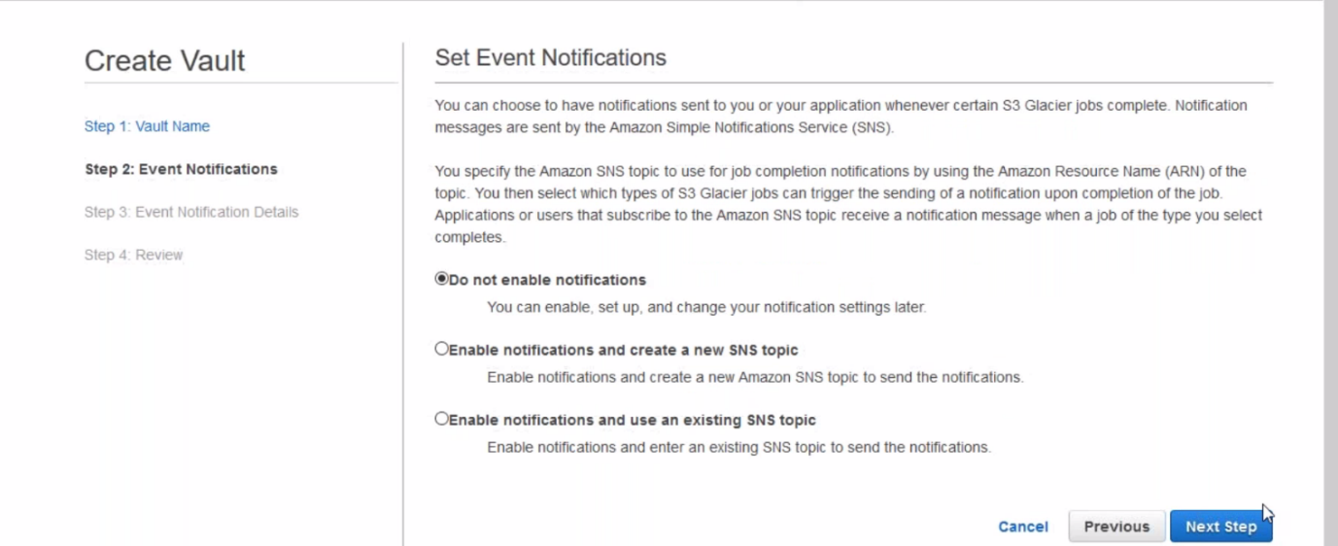

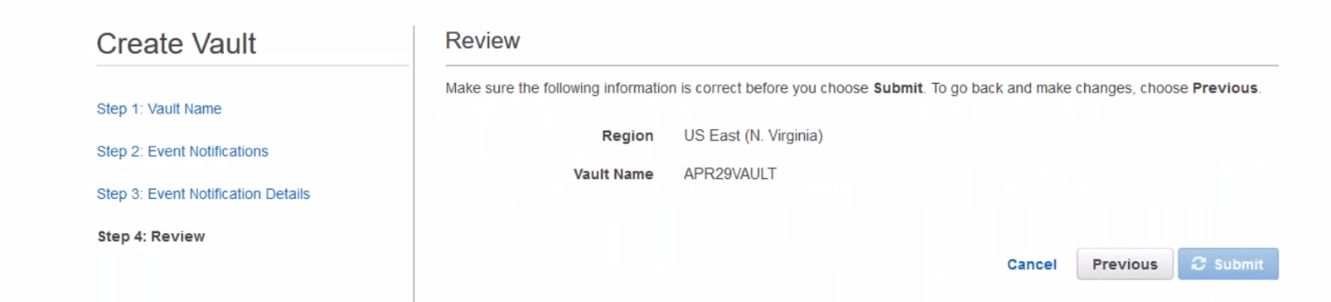

--- volt will be created.

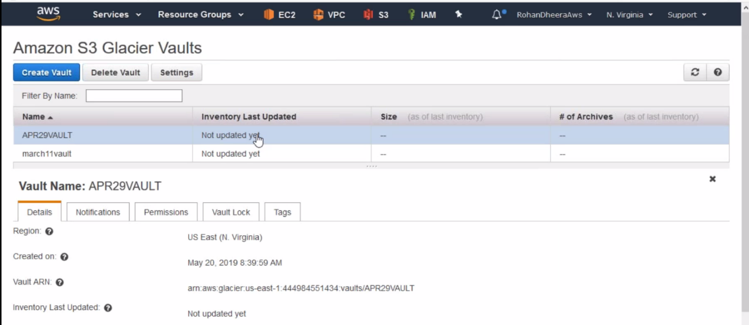

--- from here you cannot upload data to glacier.

--- 2 ways you can upload data to glacier 1.S3 life cycle policy 2.through API (any 3rd part tool)

**Connecting to AWS-S3 glacier using 3rd party tool**

**Fast glacier tool**

We can use this tool to connect S3 glacier

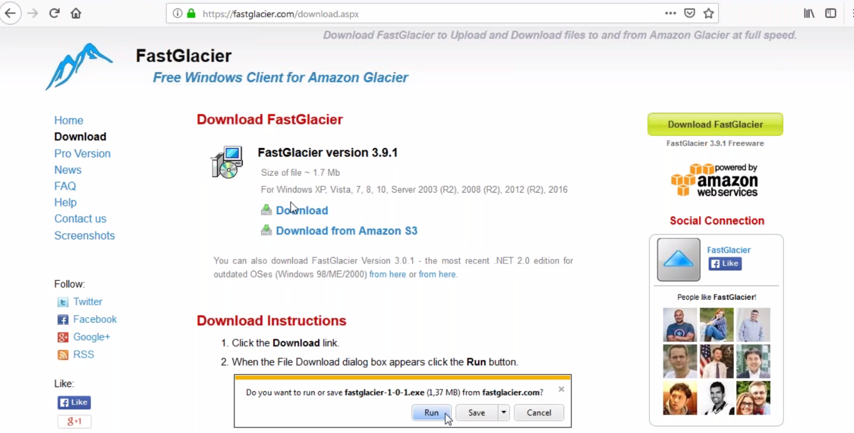

--- download this tool and open it.

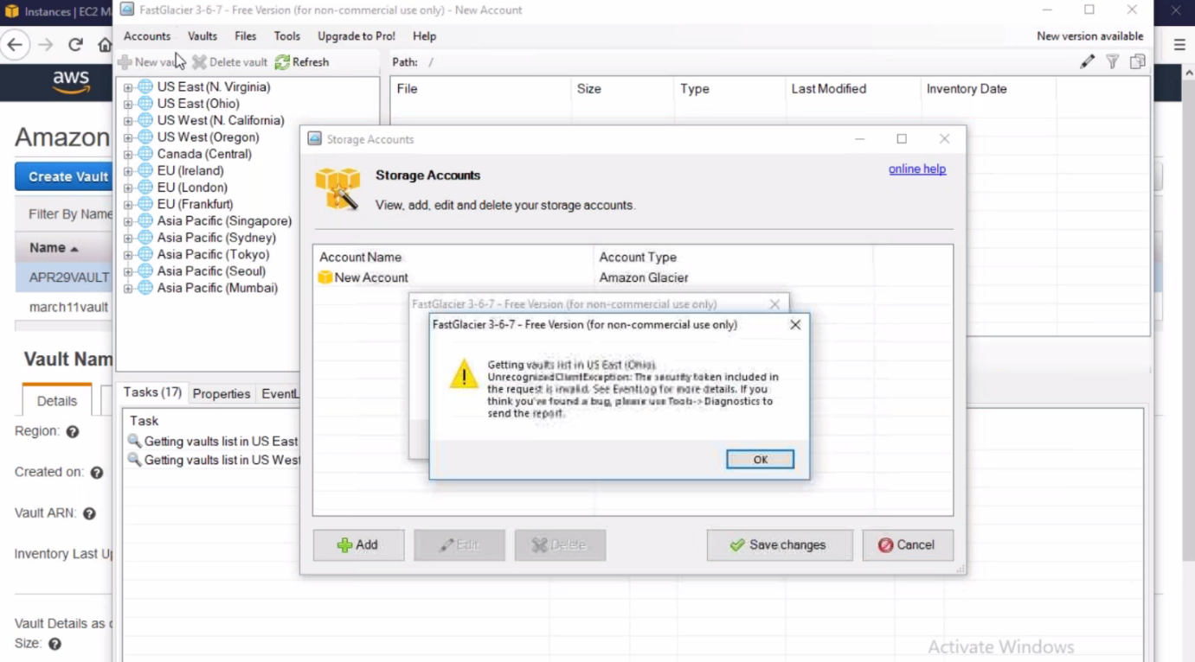

--- click on accounts and then click on add accounts.

--- connecting to AWS -S3 glacier we need access key and secret key.

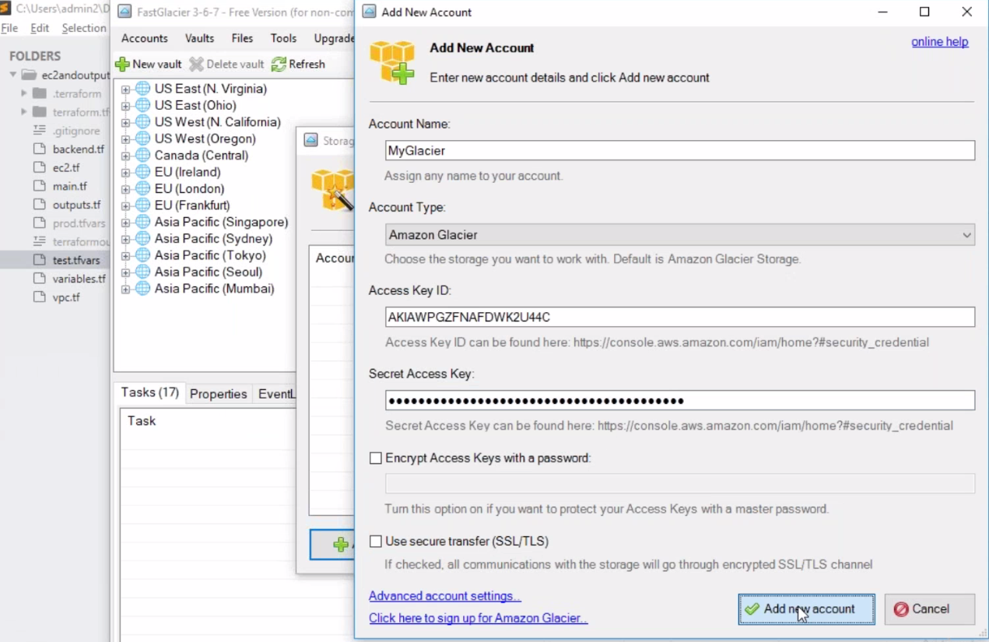

--- paste the access and secret key.

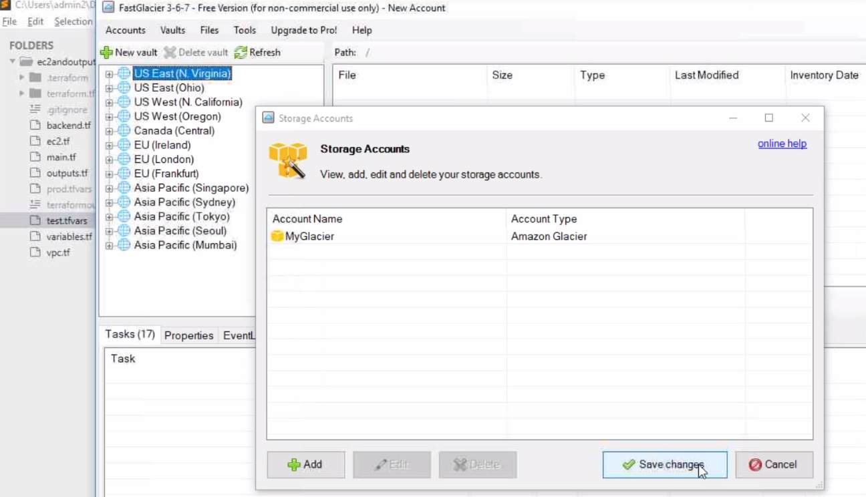

--- click on save changes.

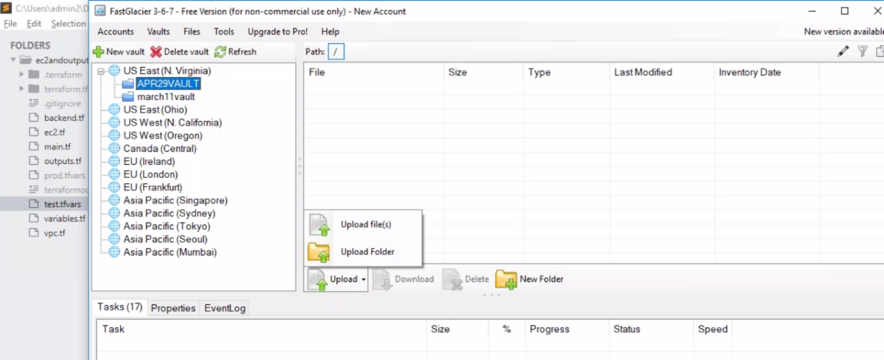

--- it will show 2 volts that we created earlier. You want to upload the data then click on upload.

**Taking the data from S3-glacier**

By default, data is not ready for download we need to retrieve the data

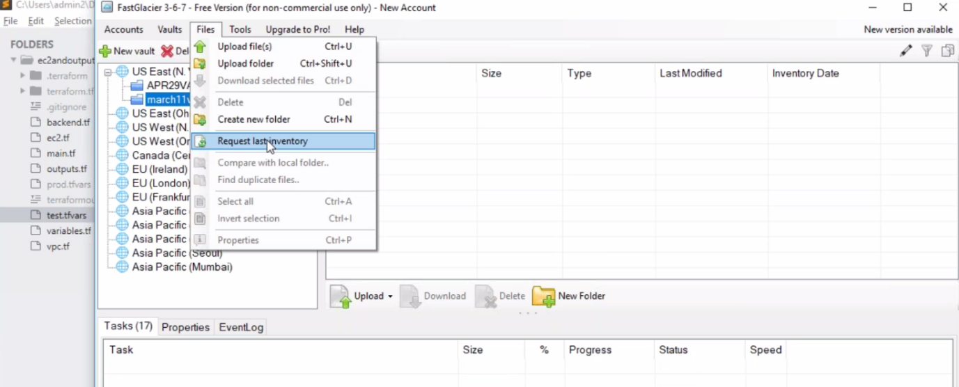

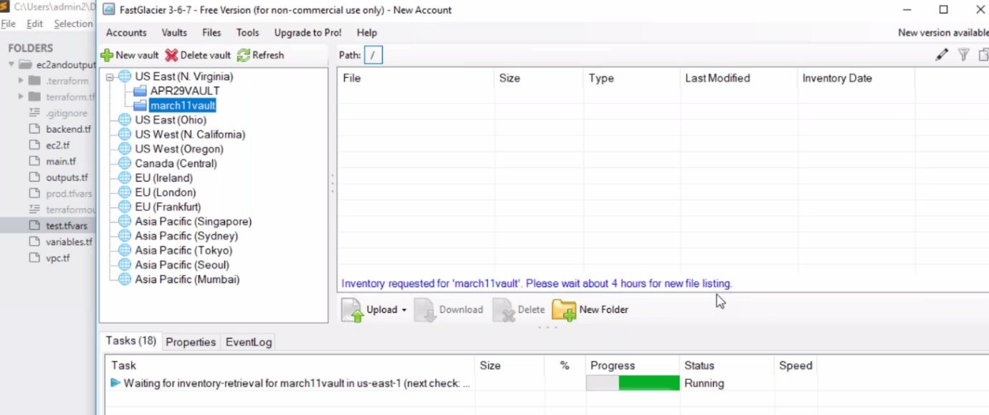

**Storage Gateway**

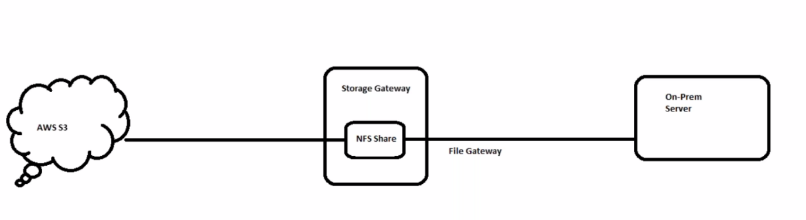

the NFS share is present in the storage gate way. The storage gate way is connected to the on-prem server. In the back end the storage gate way is move the date to AWS S3

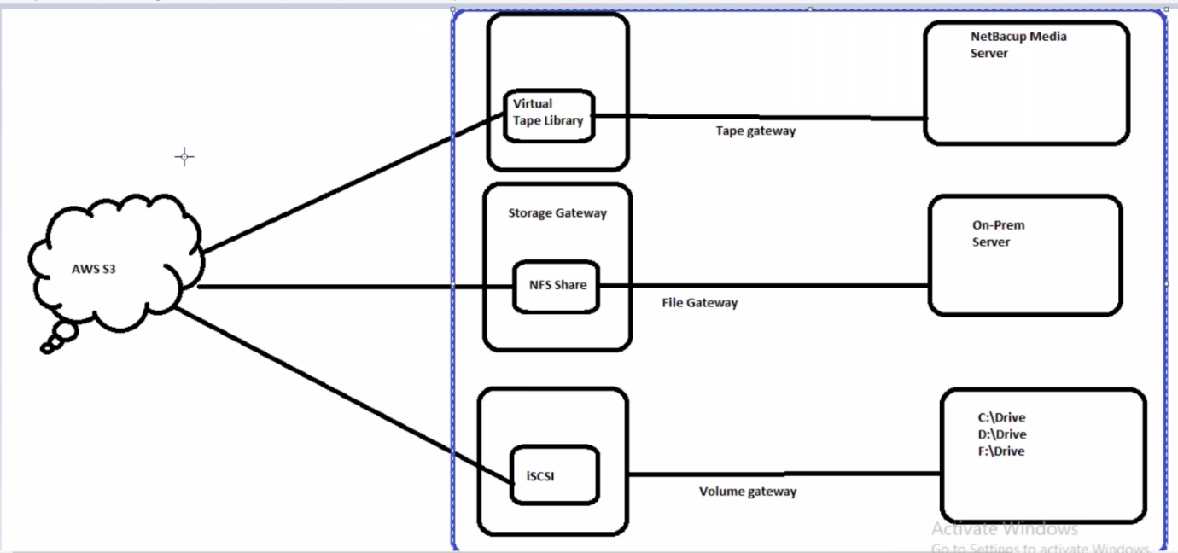

Three ways we use storage gate way. We place this on-premises

Or

we can maintain this setup on AWS

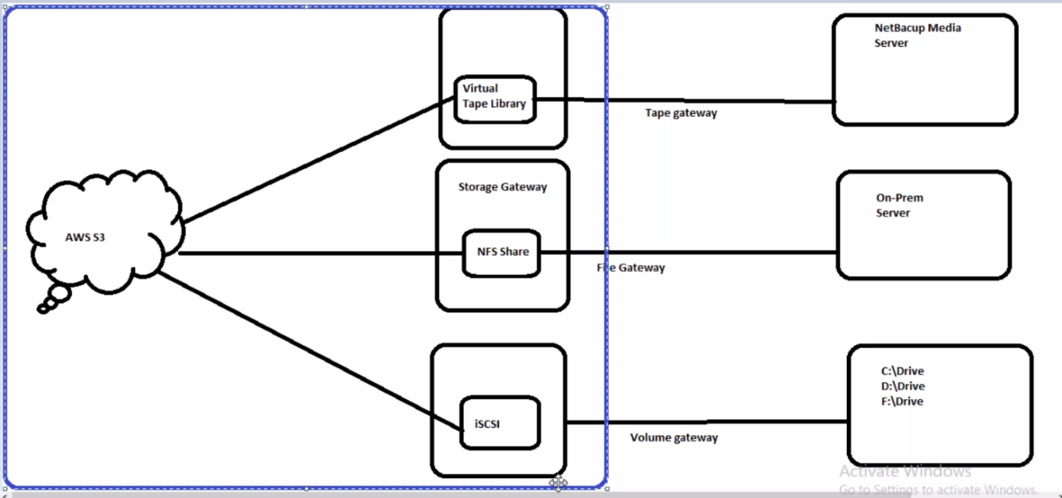

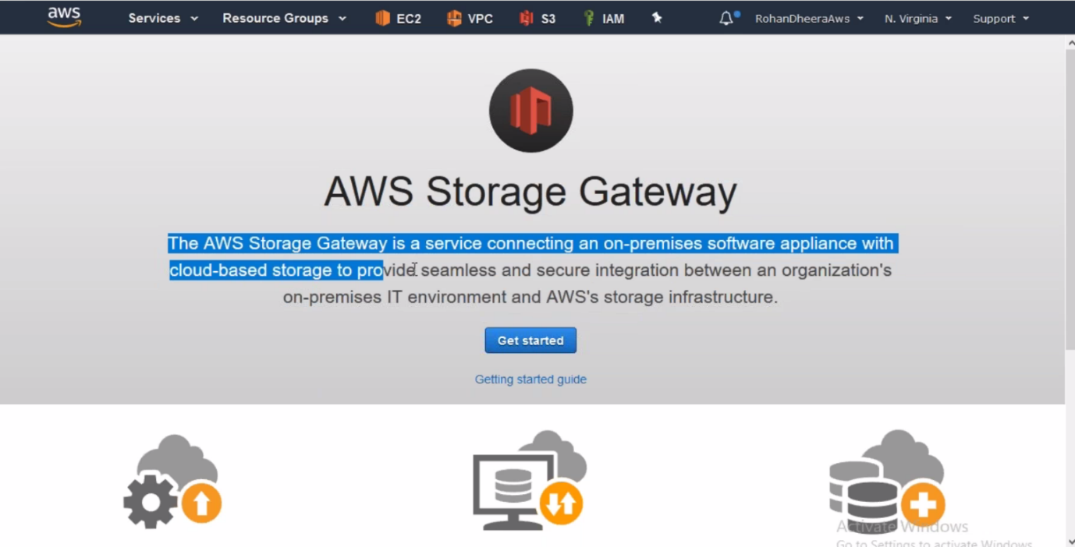

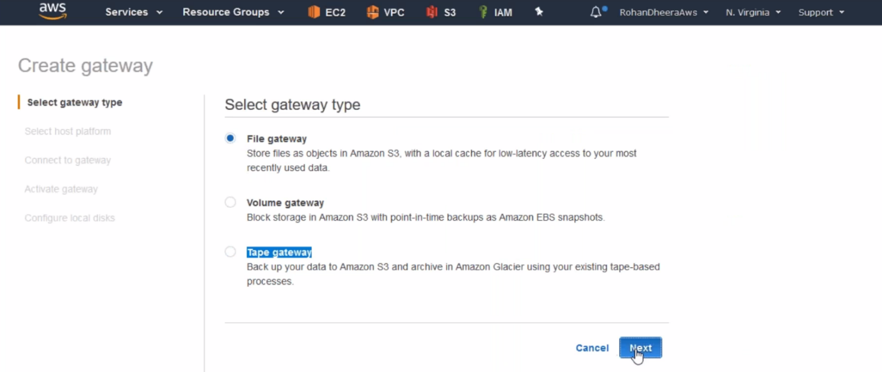

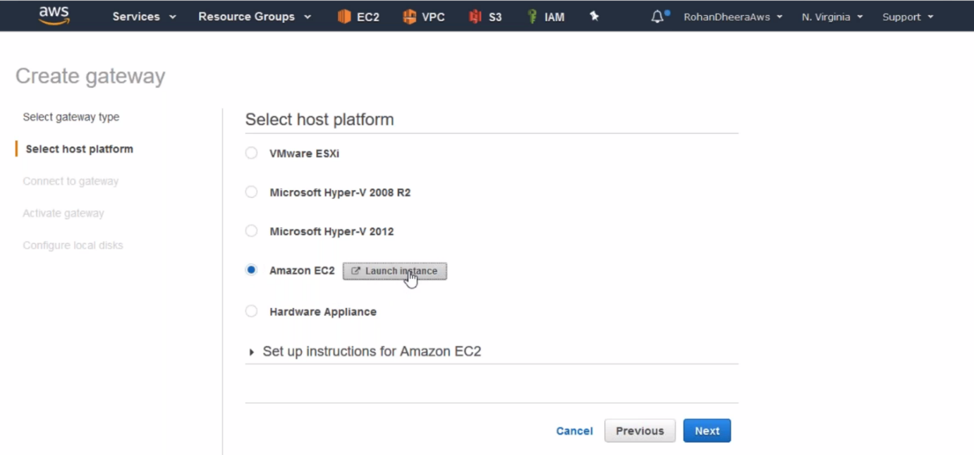

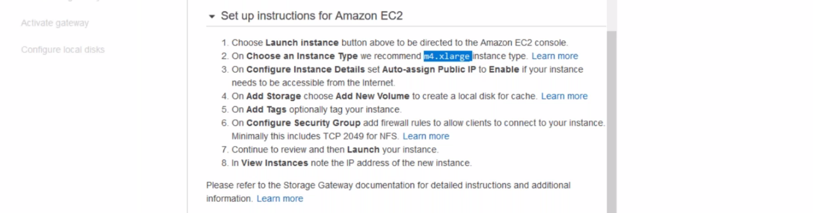

--- Instruction for launching an instance.

--- launch the instance using above instruction with 50GB EBS.

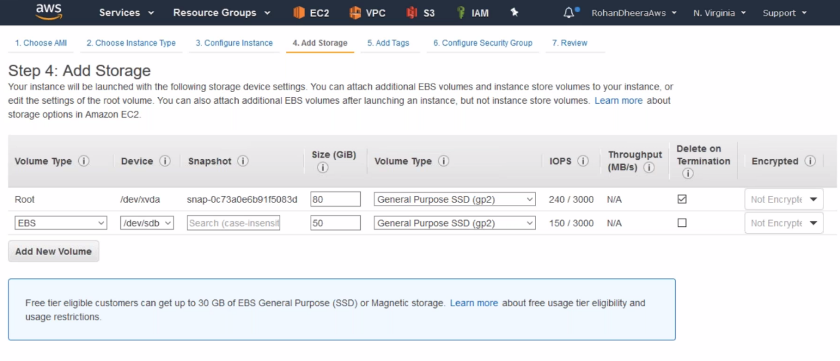

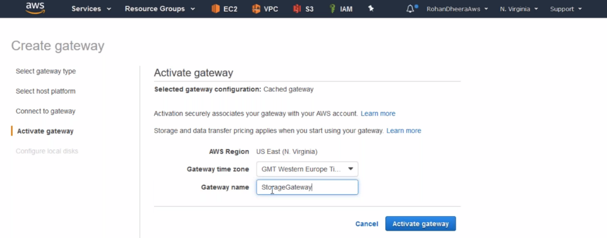

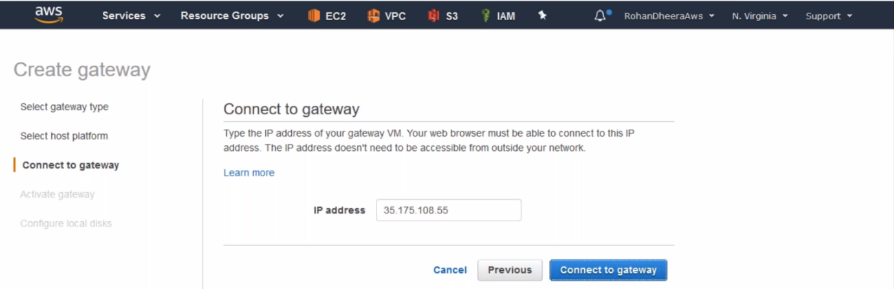

--- copy the public IP address of instance that we just created.

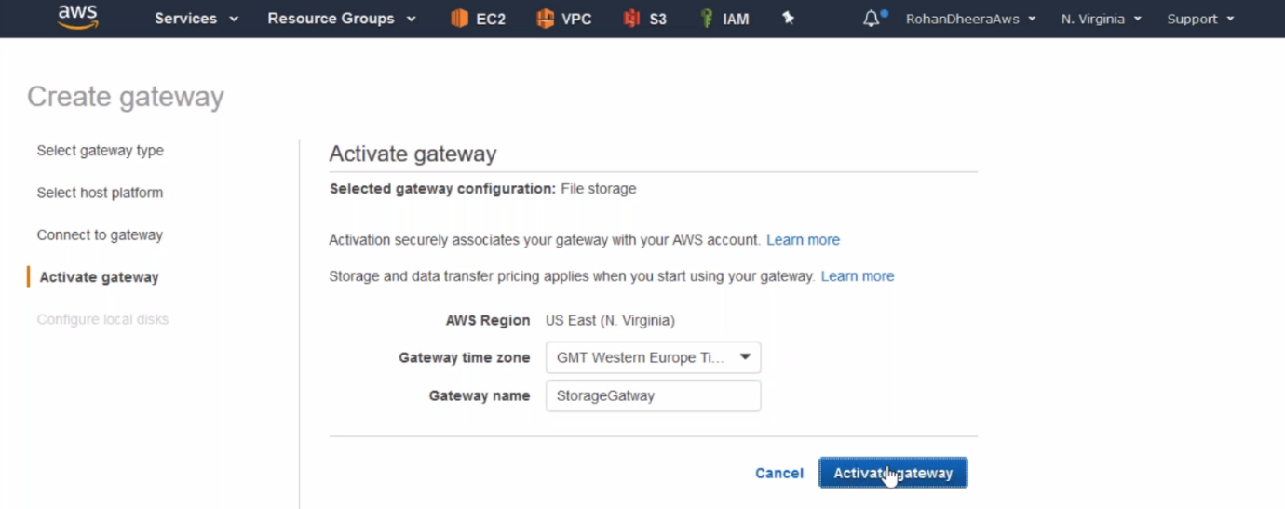

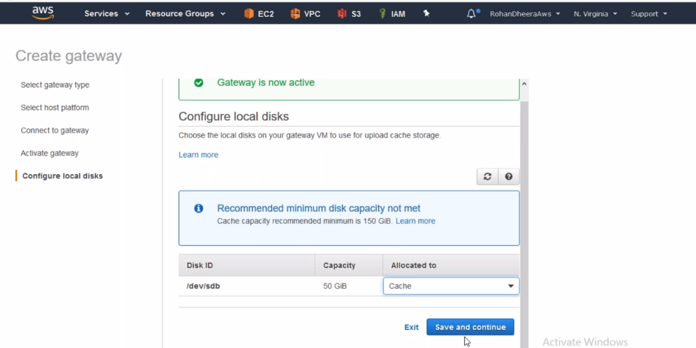

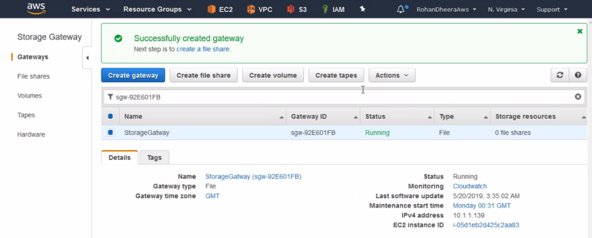

--- gateway is created successfully.

**Creating file share**

Here you will get error when will try to create volume, tapes because it’s not volume or tapes gate way

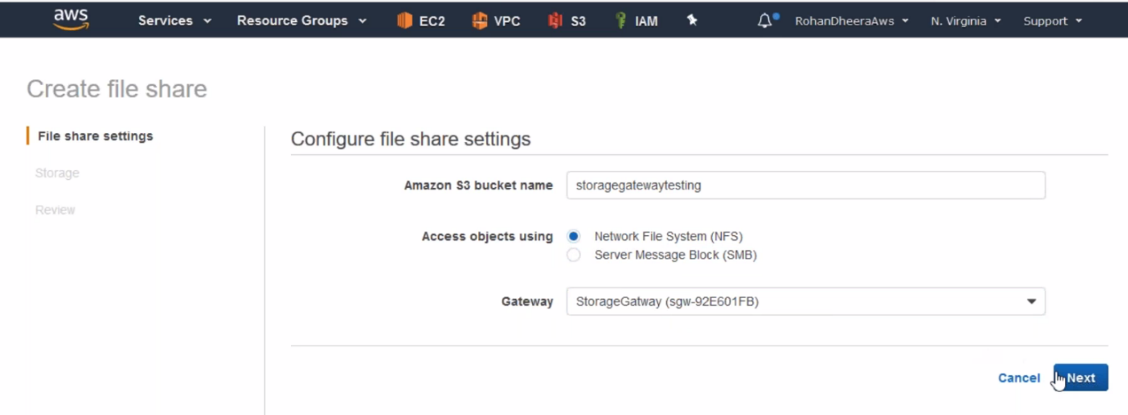

--- NFS for LINUX and SMB for windows

--- Create S3 bucket if you want a new one

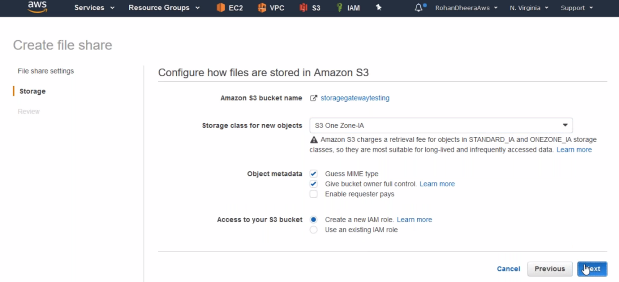

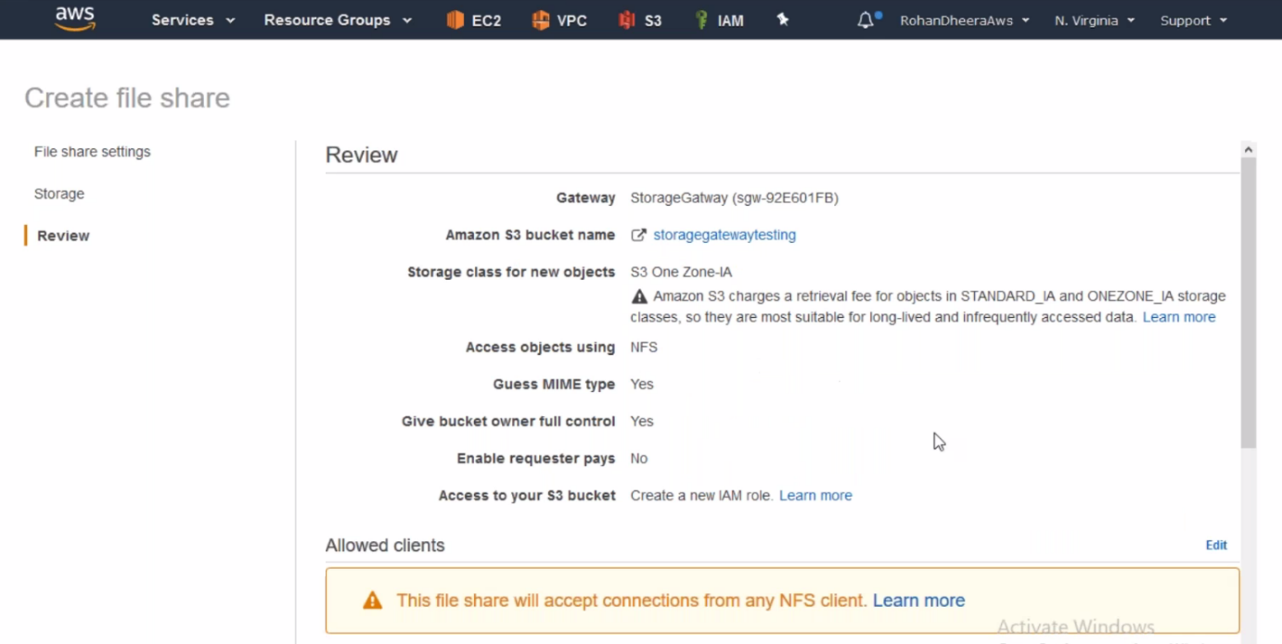

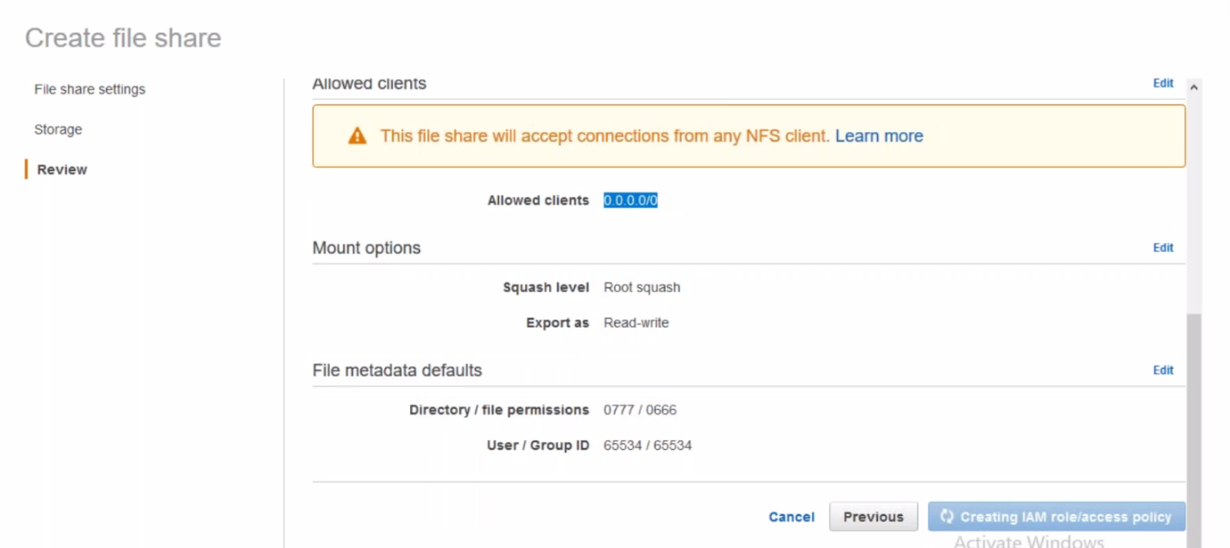

--- we can also allow specific subnet here.

**Mounting file share on an instance**

--- login to an instance new one

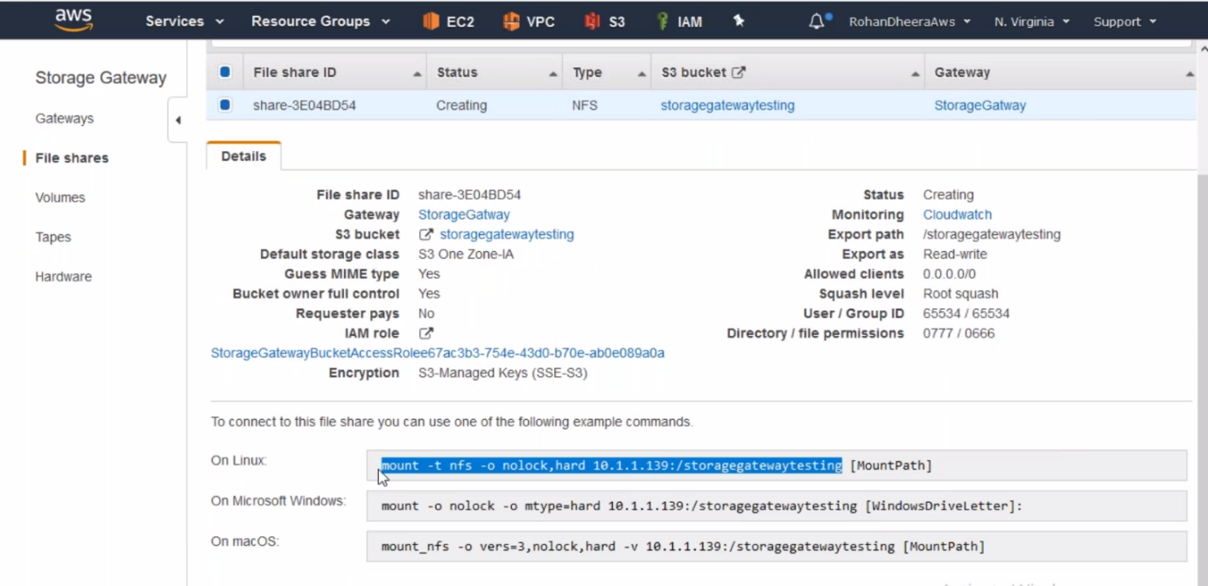

--- **mkdir sgtesting** – creating folder and we will mount file share to this folder.

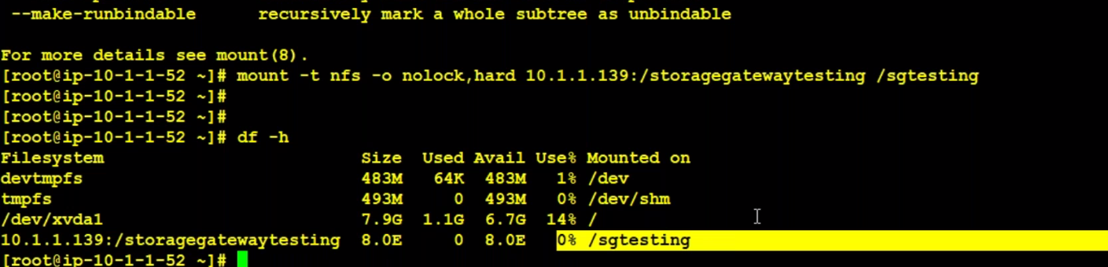

--- now you can see the storagegatewaytesting is mounted on sgtesting.

--- now try to create a file in sgtesting it will moved to S3

**AWS Backup**

This is for AWS RDS, dynamo DB, EFS…etc

In case of LIFE CYCLE MANAGER is only for EC2

Back up is nothing but it will create a snapshot automatically

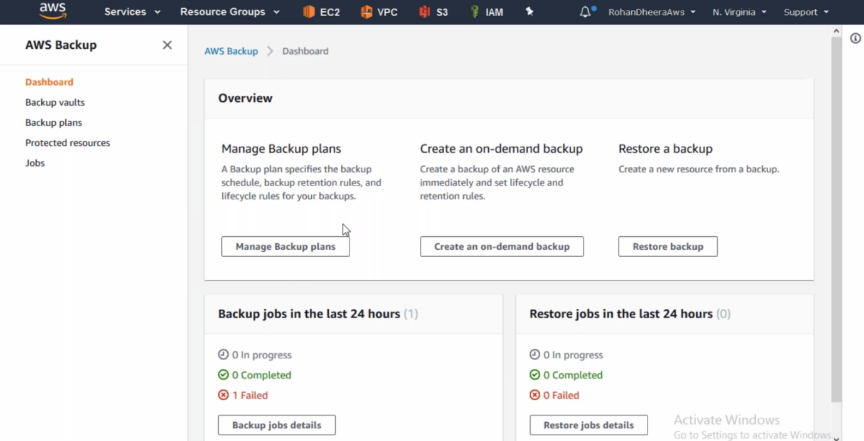

--- here we can create data backup plans.

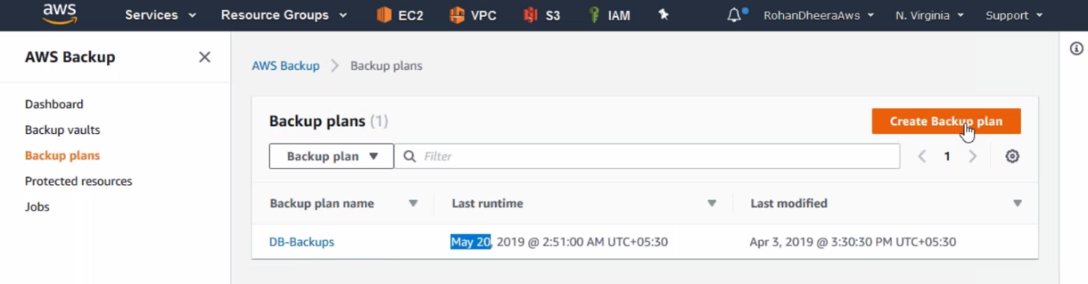

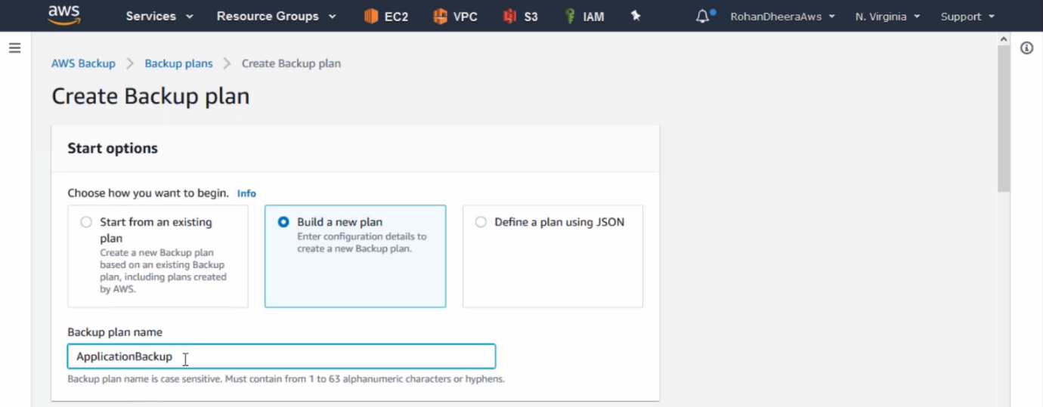

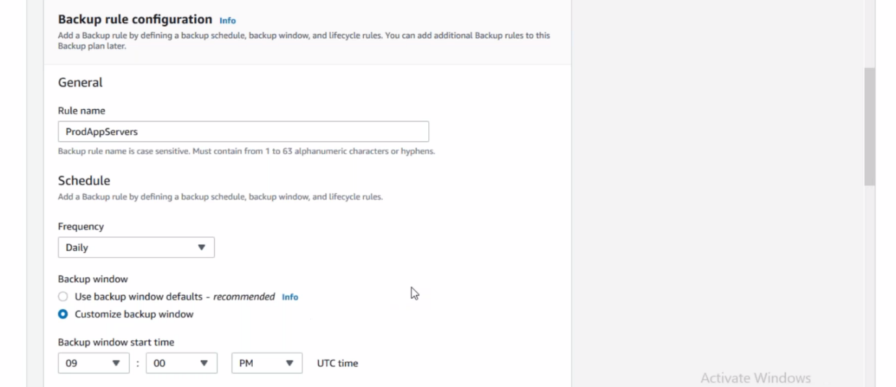

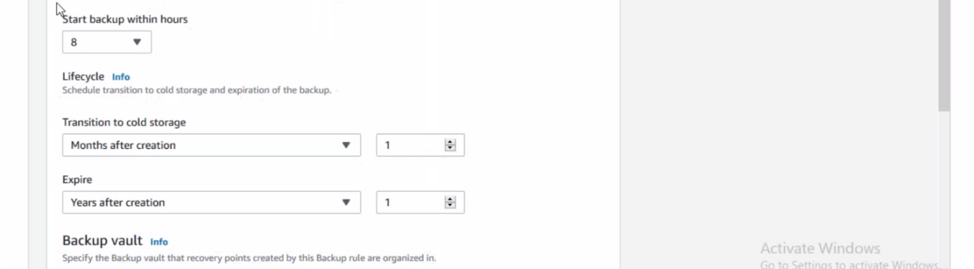

--- leave default for backup vault.

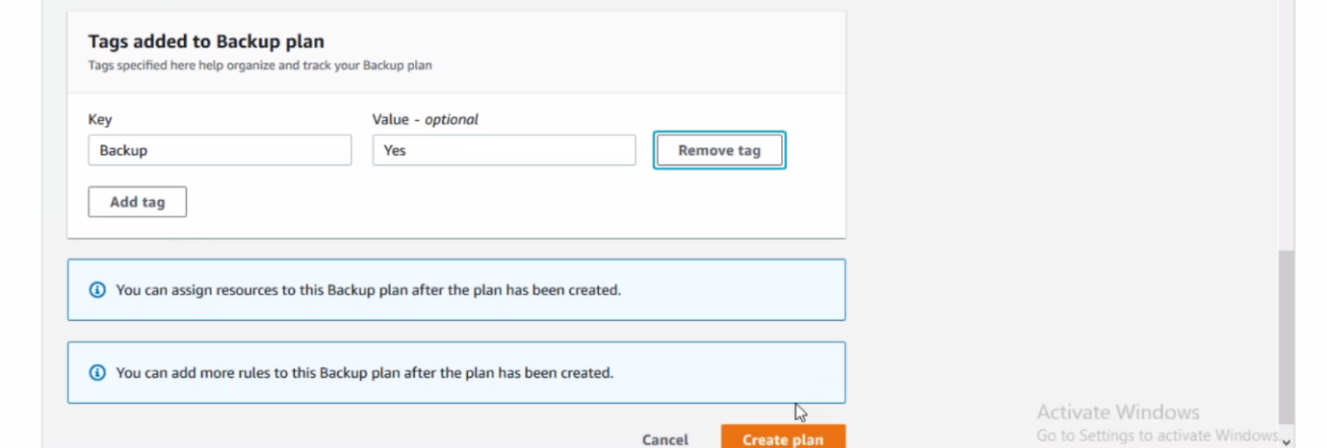

--- click on create plan, plan will be created successfully

**Assigning backup plan**

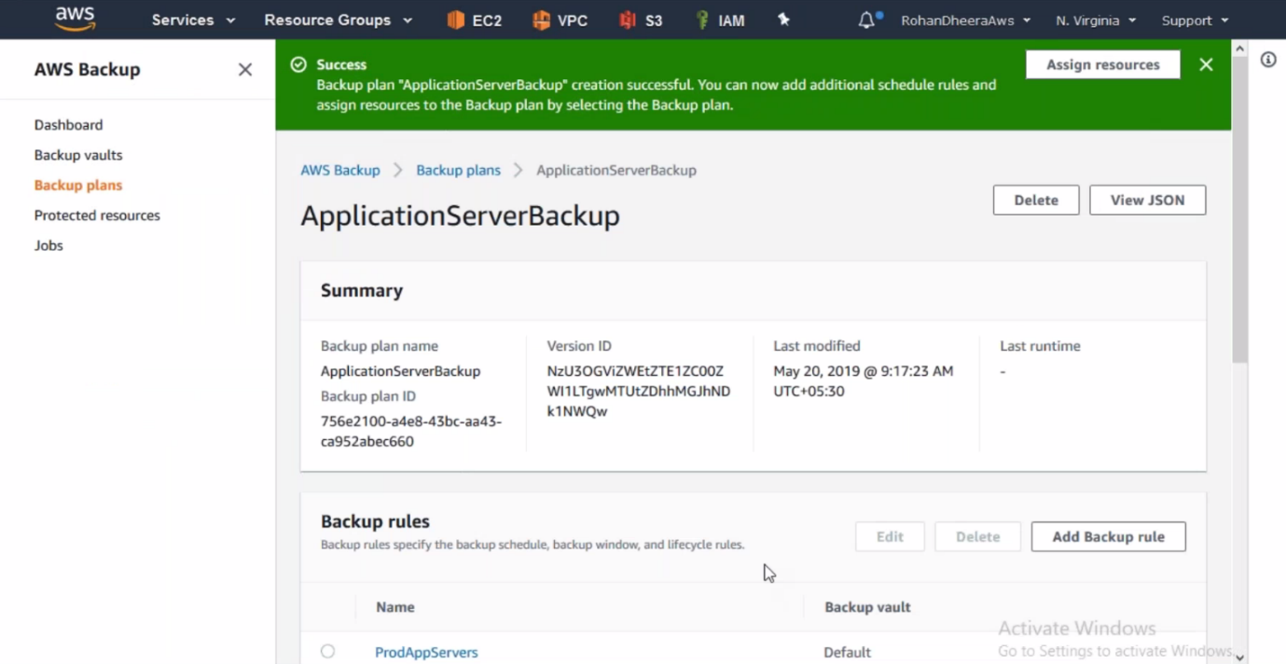

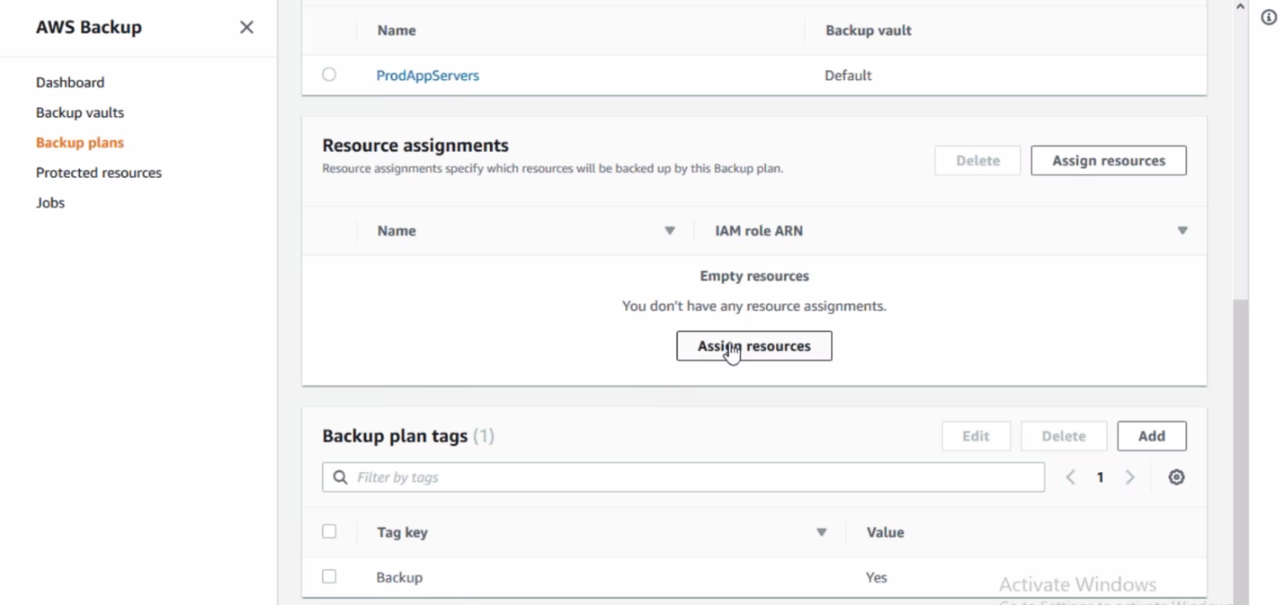

--- here this plan assigned which server having the BACKUP is YES or we can assign by clicking on assign resource.

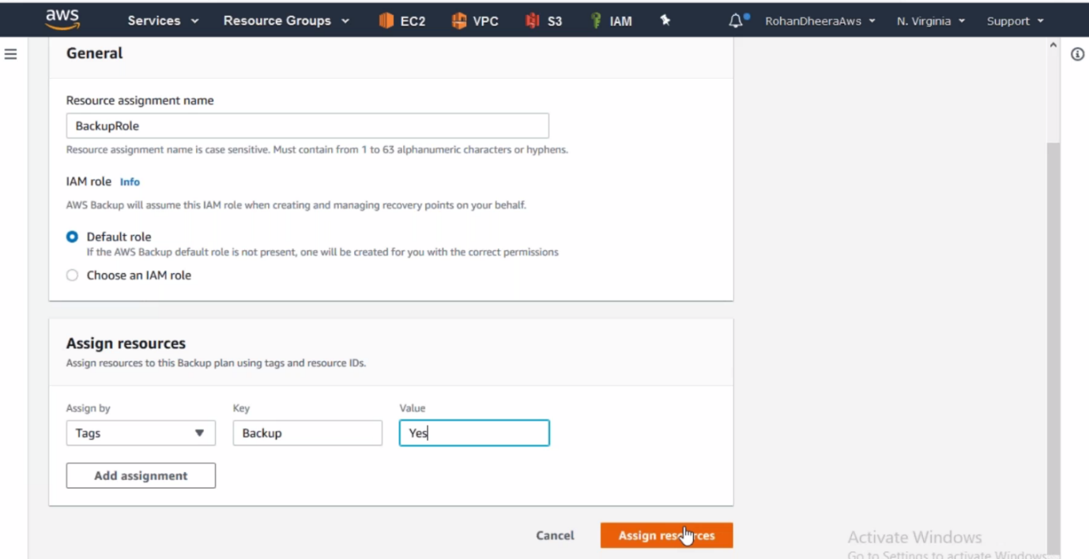

--- the role will be assigned.

**On demand backup**

We can take backup for Dynamo DB, EBS, EFS, RDS, Storage Gate way from here

